Agile Project Documentation

Title Page
AI Career Companion Agent for Internship Matching and Interview Preparation

Project Title:
AI Career Companion Agent

Prepared By:
Aswini.S

Project Duration:
22/07/2026 - 22/09/2026

Mentor:
Vijay Parmar

S.No. | Section | Page No.
1 | Project Overview | 3
2 | Project Objective | 3
3 | Technology Stack | 4
4 | Project Requirements | 5
5 | System Architecture / Workflow | 6
6 | Product Backlog | 7
7 | Sprint Planning | 8
8 | Sprint Tasks & Status | 10
9 | Implementation / Key Features | 11
10 | Testing | 12
11 | Challenges & Solutions | 13
12 | Final Project Status | 14

Project Overview

Project Name
AI Career Companion Agent for Internship Matching and Interview Preparation

What is the Project?
AI Career Companion Agent is a full-stack career assistance platform for internship seekers. It accepts candidate profile and resume information, extracts relevant skills from PDF or DOCX files, matches candidates with internships using vector search, and provides AI-assisted career guidance and interview preparation.
The platform also supports document upload and question answering, role recommendations, skill-gap analysis, cover-letter generation, and an internship assistant chat experience.

Problem Statement
Internship seekers often spend significant time manually comparing their resumes with job descriptions,
identifying suitable roles, preparing for interviews, and writing application documents. Generic job searches also make it difficult to understand why a role is a good fit or which skills need improvement.
This project addresses the problem by combining resume parsing, structured candidate data, FAISS vector matching, and AI-generated guidance in one application.

Target Users
    - Students and recent graduates seeking internships
    - Candidates preparing for technical or HR interviews
    - Career mentors supporting internship applicants
    - Training and placement teams

Project Objective
The objective is to provide a single, practical workspace that helps candidates move from resume upload to internship discovery and interview preparation.

Objectives
- Allow users to create an account and maintain a career profile.
- Extract useful candidate information from PDF and DOCX resumes.
- Match candidate skills with relevant internship opportunities using vector search.
- Provide role recommendations, skill-gap analysis, interview preparation, and cover letters.

- Allow users to ask questions about uploaded career documents.
- Provide a simple React dashboard connected to FastAPI APIs.

Technology Stack

Category | Technology Used
Programming Language | Python, JavaScript (JSX)
Backend Framework | FastAPI, Uvicorn
Frontend Framework | React 19, Vite
Routing | React Router DOM with HashRouter
HTTP Client | Axios
Database | SQLAlchemy with PostgreSQL or SQLite fallback
Authentication | JWT using python-jose; password hashing using pwdlib Argon2
Resume and Document Processing | PyMuPDF, python-docx
Embeddings | Sentence Transformers, all-MiniLM-L6-v2
Vector Database / Search | FAISS (faiss-cpu)
AI / LLM Integration | OpenAI Python SDK
Data Validation | Pydantic and pydantic-settings
API Documentation | FastAPI OpenAPI and Swagger UI
Deployment / Hosting | Render backend and GitHub Pages frontend, as documented in the project README
Version Control | Git and GitHub

Project Requirements

Functional Requirements
    - Users can register and log in.
    - Users can maintain profile information such as education, skills, bio, and phone number.
    - Users can upload PDF and DOCX resumes.
    - The system extracts resume text and structured candidate information.
    - The system stores resumes and extracted data in the database.
    - The system seeds and indexes internship data from a CSV dataset.
    - Users can search for internship matches using candidate resume data.
    - Users can request AI-based role recommendations and interview preparation.
    - Users can perform skill-gap analysis for a target role.
    - Users can generate a tailored cover letter.
    - Users can upload career documents and ask document-related questions.
    - Users can interact with an internship assistant.

Non-Functional Requirements
    - The application should provide clear validation errors for unsupported or empty files.
    - Authentication data should be protected with hashed passwords and JWT tokens.
    - The user interface should be responsive and easy to navigate.
    - APIs should expose predictable JSON responses and OpenAPI documentation.
    - The system should support PostgreSQL while allowing local SQLite development.
    - AI responses should be grounded in available candidate or document context where applicable.

System Architecture / Workflow

5.1. System Architecture / Workflow

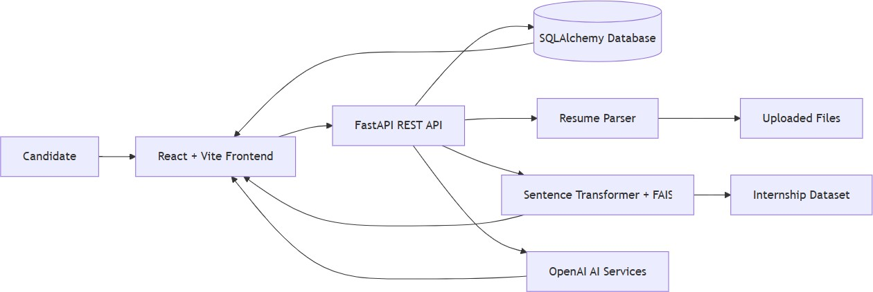

Resume and Internship Matching Workflow
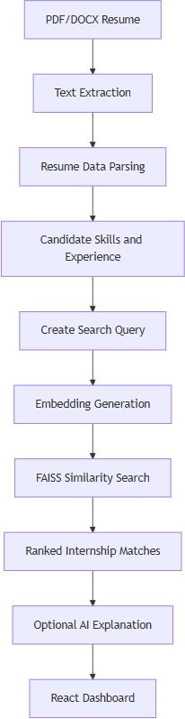

Document Question-Answering Workflow
    - The user uploads a PDF or DOCX document.
    - The backend validates the file extension and content.
    - Text is extracted and stored with document metadata.
    - The AI service creates a summary and suggested questions.
    - The user submits a question for the selected document.
    - The backend returns an answer, summary, and suggested questions.

Main API Flow
- User -> React Frontend -> Axios -> FastAPI Route -> Database / Parser / FAISS / AI Service -> JSON Response -> React UI
- Important route groups include /api/auth, /api/profile, /api/resume, /api/internships, /api/career, and /api/documents.

Product Backlog

ID | Feature / Task | Priority | Status
P001 | Project structure and development environment | High | Done
P002 | Database models and SQLAlchemy integration | High | Done
P003 | User registration and JWT login | High | Done
P004 | Profile management | Medium | Done
P005 | PDF and DOCX resume upload | High | Done
P006 | Resume text extraction and parsing | High | Done
P007 | Internship CSV seeding | High | Done
P008 | Sentence Transformer and FAISS matching | High | Done
P009 | AI role recommendations | High | Done

ID | Feature / Task | Priority | Status
P010 | Interview preparation generation | High | Done
P011 | Skill-gap analysis | Medium | Done
P012 | AI cover-letter generation | Medium | Done
P013 | Document upload and document Q&A | High | Done
P014 | React dashboard and API integration | High | Done
P015 | Internship assistant chat | Medium | Done
P016 | Automated regression test suite | High | To Do
P017 | Production hardening and deployment monitoring | Medium | In Progress

Sprint Planning

Sprint 1 - Project Setup
Duration: 1 week
Goal: Establish the application structure and development environment.

Tasks:
- Understand internship matching and interview preparation requirements.
- Create the backend and frontend project structure.
- Set up the Python environment and npm project.
- Configure database settings and application configuration.
- Set up Git and the GitHub repository.

Sprint 2 - Backend and Authentication
Duration: 1 week
Goal: Build the core API and candidate data layer.

Tasks:
- Create FastAPI application entry point.
- Create SQLAlchemy models and database initialization.
- Implement registration and JWT login.
- Implement profile management APIs.
- Implement resume upload validation and storage.

Sprint 3 - AI, RAG, and Career Features
Duration: 1 week
Goal: Implement resume intelligence and career assistance.

Tasks:
- Extract and parse resume content.
- Seed internship data from CSV.
- Generate embeddings and build the FAISS index.
- Implement internship matching and optional explanations.
- Implement role recommendations and interview preparation.
- Implement document Q&A and cover-letter generation.

Sprint 4 - Frontend Integration and Testing
Duration: 1 week
Goal: Integrate the dashboard and prepare the application for demonstration.

Tasks:
- Integrate React screens with backend APIs.
- Add resume, internship, profile, and AI assistant workflows.
- Add loading, error, and fallback states.
- Perform API, UI, integration, and AI response checks.
- Fix defects and prepare the final demonstration.

Sprint Tasks & Status

Sprint | Task | Assigned To | Status
Sprint 1 | Project structure and environment setup | Project Intern | Done
Sprint 1 | Database configuration and models | Project Intern | Done
Sprint 2 | Authentication APIs | Project Intern | Done
Sprint 2 | Profile and resume APIs | Project Intern | Done
Sprint 3 | Resume parsing | Project Intern | Done
Sprint 3 | FAISS internship matching | Project Intern | Done
Sprint 3 | AI career agent endpoints | Project Intern | Done
Sprint 3 | Document Q&A workflow | Project Intern | Done
Sprint 4 | React dashboard integration | Project Intern | Done
Sprint 4 | Automated regression tests | Project Intern | To Do
Sprint 4 | Deployment and monitoring hardening | Project Intern | In Progress

Implementation / Key Features

Feature 1: User Authentication and Profile

Description:
- Users can register, log in, and maintain profile information used by the career assistant.

Implementation:
- FastAPI authentication routes use JWT access tokens. Passwords are hashed with Argon2
through pwdlib. SQLAlchemy models persist user and profile data. The React application manages the login, registration, and dashboard states.

Output:
- Login and registration screens are available in the React application. Successful authentication stores an access token in browser local storage.

Feature 2: Resume Upload and Parsing

Description:
- Users can upload PDF or DOCX resumes for structured extraction.

Implementation:
- The resume route validates file type and content, saves the file, extracts text with PyMuPDF
or python-docx, parses candidate information, and stores the extracted data in the database. Invalid extensions, empty files, and parsing failures return clear HTTP errors.

Output:
- The dashboard can display uploaded resumes and extracted candidate information for later matching and AI operations.

Feature 3: Internship Matching

Description:
- The system recommends internships that align with a candidate's resume and skills.

Implementation:
- Internship records are loaded from backend/data/internships.csv. Candidate and internship information is embedded with Sentence Transformers. FAISS performs similarity search and returns ranked matches. An optional AI explanation can be generated for the result.

Output:
- The Internships view displays available opportunities, filters, and matched jobs.

Feature 4: AI Career Agent

Description:
- The career agent helps candidates select roles and prepare for interviews.

Implementation:
- The FastAPI career routes expose role recommendations, interview preparation, skill analysis, cover-letter generation, and internship assistant chat. Candidate resume data is used as context where available, with a controlled fallback profile for demo use.

Output:
- Users can receive recommended roles, interview questions, preparation guidance, skill-gap feedback, and tailored cover letters.

Feature 5: Document Q&A

Description:
- Users can upload a career-related document and ask questions about its content.

Implementation:
- The document route accepts PDF and DOCX files, extracts and stores their text, generates a summary and suggested questions, and returns an answer for subsequent questions.

Output:
- The document workspace shows the extracted summary, question history, and AI answers.

Testing

Test Cases

Test ID | Test Case | Expected Result | Current Result | Status
T001 | Register with valid user details | User account is created | Registration route and UI are implemented | Testing
T002 | Login with valid credentials | JWT access token is returned | Login route and token handling are implemented | Testing
T003 | Upload a valid PDF resume | Resume is stored and parsed | PDF validation and parsing are implemented | Testing
T004 | Upload a valid DOCX resume | Resume is stored and parsed | DOCX validation and parsing are implemented | Testing
T005 | Upload an unsupported file | Error message is shown | API returns HTTP 400 | Done
T006 | Match a candidate with internships | Ranked matches are returned | FAISS matching route is implemented | Testing
T007 | Request interview preparation | Role-specific preparation is returned | Career agent route is implemented | Testing
T008 | Ask a question about an uploaded document | Contextual answer is returned | Document Q&A route is implemented | Testing
T009 | Upload an empty file | Validation error is shown | API returns HTTP 400 | Done
T010 | Check API health endpoint | status: ok is returned | /health endpoint is implemented | Done

Testing Types
    - Functional testing of authentication, uploads, matching, and AI workflows
    - API testing using FastAPI Swagger UI or an API client
    - UI testing of React dashboard interactions
    - Integration testing between the React frontend and FastAPI backend
    - AI/RAG testing for match relevance, answer quality, and prompt behavior
    - Negative testing for unsupported, empty, and unreadable files

Challenges & Solutions

Challenge | Solution
PDF and DOCX files require different extraction approaches | Used PyMuPDF for PDF extraction and python-docx for DOCX extraction behind a common upload workflow.
Candidate data is unstructured in resumes | Added a parsing layer that converts extracted text into structured fields such as skills, education, and experience.
Internship matching needs more than keyword comparison | Used Sentence Transformer embeddings and FAISS similarity search to rank semantically related opportunities.
AI features need candidate context | Career routes first attempt to load the selected or latest resume and use fallback candidate data only when no resume is available.
Frontend should remain usable when an API is unavailable during demonstration | Added frontend fallback and demo states for selected assistant and authentication interactions.
Local and hosted environments may use different databases | Configured SQLAlchemy to support PostgreSQL while allowing SQLite fallback for local development.
Formal automated regression coverage is not yet present | Identified a dedicated test-suite backlog item for API, UI, and AI/RAG regression tests.

Final Project Status

Completed Features
- React dashboard and navigation
- User registration and JWT login flow
- Profile management interface and API
- PDF and DOCX resume upload
- Resume text extraction and structured parsing
- Internship dataset seeding and FAISS matching
- AI role recommendations
- Interview preparation generation
- Skill-gap analysis
- Cover-letter generation
- Document upload and document Q&A
- Internship assistant chat
- FastAPI OpenAPI / Swagger documentation

In Progress
- Production monitoring and deployment hardening
- Repeatable automated API and UI validation
- Broader evaluation of AI response quality and match relevance

Pending
- Dedicated automated regression test suite
- Expanded production security review and rate limiting
- Additional observability and operational documentation

Final Outcome
The project provides a working full-stack AI career companion for internship seekers. A user can create an account, maintain a profile, upload a resume, view extracted information, discover vector-based internship matches, request role recommendations, prepare for interviews, generate a cover letter, and ask questions about uploaded documents.

The core application workflow and API surface are implemented. The next project phase should focus on formal automated testing, production hardening, monitoring, and systematic evaluation of AI and internship-match quality.

